Air Conditioning Engineering — Topic 1.1: Definition, Purpose, and Scope
Air Conditioning Engineering, CMU
2026
Table of Contents

1.1 Air Conditioning — Definition, Purpose, and Scope

1.1.1 Definition of Air Conditioning
Air conditioning is the engineering process of simultaneously controlling four physical properties of air within a defined space to maintain conditions suitable for the intended use:
- Temperature — maintaining dry-bulb temperature within a comfortable or process-required range
- Humidity — controlling moisture content (relative humidity, %RH) to prevent discomfort, condensation, or process damage
- Air Circulation — distributing conditioned air uniformly and supplying adequate fresh outdoor air
- Air Cleanliness — removing dust, allergens, microorganisms, and gaseous contaminants through filtration
Source: Praphan, Chapter 1, p. 1
Figure 1.1 illustrates the four parameters that an air conditioning system must control simultaneously. The loss of control over any single parameter results in an environment that fails to meet design criteria, regardless of how well the others are managed.
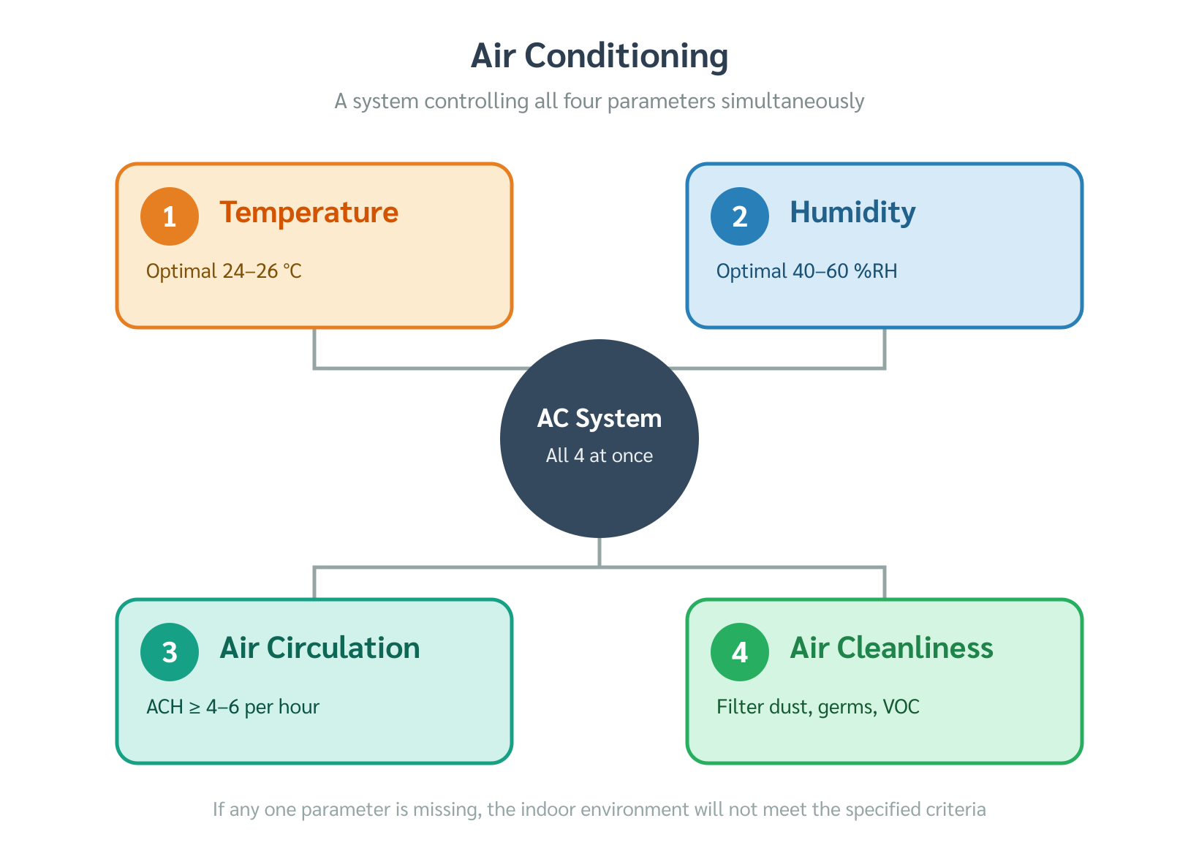
Four parameters of air conditioning
Figure 1.1 — The four parameters of air conditioning that must be controlled simultaneously. (Source: Praphan, Ch. 1, p. 1)
A critical distinction: air conditioning is not synonymous with cooling alone. Adding heat to a space in a cold climate, humidifying a textile mill, or dehumidifying a paper warehouse are all forms of air conditioning. Each application controls the same four parameters, but toward different target values determined by the specific use case.

1.1.2 Purpose of Air Conditioning
Air conditioning systems are designed for one of two fundamentally different objectives:

A. Comfort Air Conditioning
Comfort air conditioning maintains indoor conditions within the thermal comfort zone — the range of temperature and humidity in which the human body can maintain its core temperature of approximately 98.6 °F (37 °C) with minimal metabolic effort.
The human body continuously generates heat through metabolism. This heat must be rejected to the surroundings at a steady, moderate rate: - Too little heat rejection → the person feels hot and fatigued - Too much heat rejection → the person feels cold and uncomfortable
The body rejects heat through four mechanisms: convection, radiation, conduction, and evaporation (sweating). An effective comfort AC system creates conditions that allow all four mechanisms to operate within their natural, comfortable ranges.
Typical design targets for comfort AC in Thailand:
Parameter | Design Range (IP) | Design Range (SI)
Indoor dry-bulb temperature | 75–79 °F | 24–26 °C
Relative humidity | 50–60 %RH | 50–60 %RH
Air velocity (occupied zone) | 30–49 ft/min | 0.15–0.25 m/s
Source: Praphan, Ch. 1, p. 1; ASHRAE Standard 55
Figure 1.2 shows the effect of room temperature on human thermal comfort and work performance, illustrating why temperatures outside the 75–79 °F (24–26 °C) range lead to measurable productivity losses.
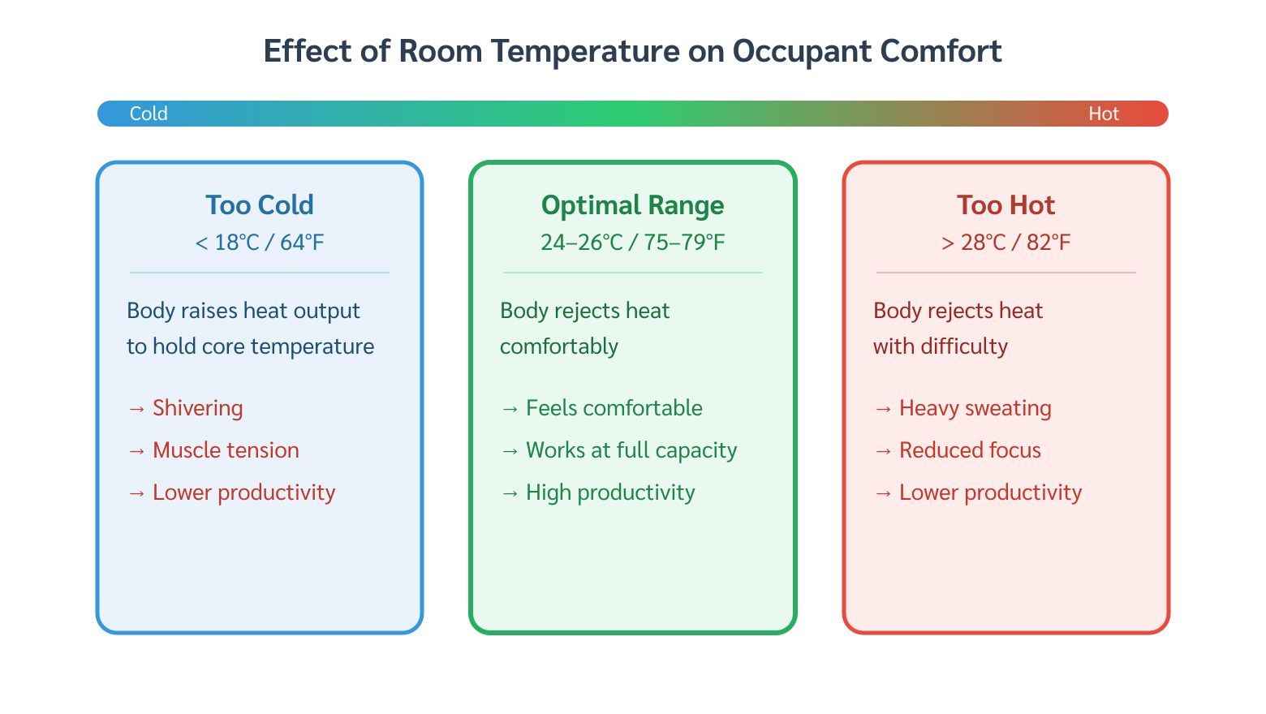
Effect of room temperature on comfort
Figure 1.2 — Effect of room temperature on thermal comfort and work performance. (Source: Praphan, Ch. 1, p. 1)

B. Process / Industrial Air Conditioning
Process air conditioning maintains indoor conditions suitable for materials, products, or manufacturing processes — not for human comfort. The controlled parameters and their target values are dictated entirely by the physical and chemical requirements of the process.
Three representative examples illustrate the diversity of requirements:
Textile mill: The weaving zone requires high relative humidity (typically 70–80 %RH). Moisture keeps synthetic and natural fibers flexible, preventing thread breakage during the weaving process. It also dissipates static electricity, which otherwise causes fibers to cling together and disrupt the loom.
Paper mill: The production and storage areas require low relative humidity. Paper is highly hygroscopic — it absorbs atmospheric moisture readily. Excess humidity causes paper to warp, cockle, and lose dimensional stability, making it unusable for precision printing or cutting.
Seed storage warehouse: Both temperature and humidity must be kept low. Elevated temperature or humidity triggers premature germination and promotes mold growth, destroying the viability of stored seeds. Typical targets are below 50 °F (10 °C) and below 50 %RH.
Source: Praphan, Ch. 1, p. 1
Figure 1.3 shows the classification of air conditioning systems by purpose, with representative building types for each category.
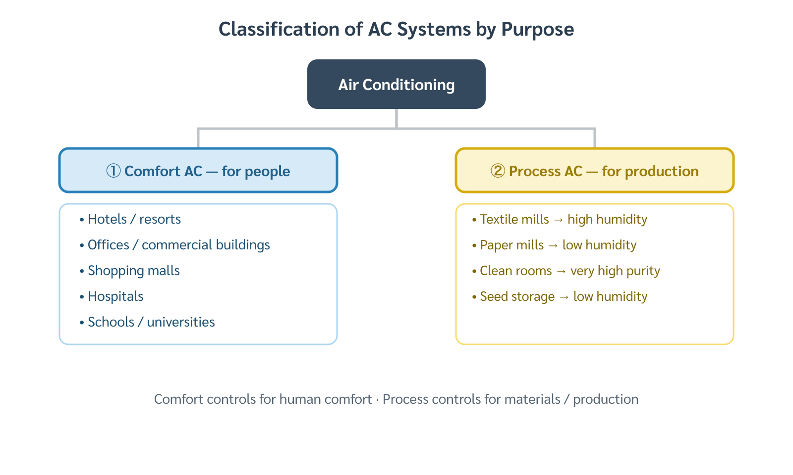
Classification of AC systems by purpose
Figure 1.3 — Classification of air conditioning systems by purpose. (Source: Praphan, Ch. 1, p. 1)

1.1.3 Equipment Sizing and Peak Load Design
Selecting an air conditioning system of the correct capacity is the central technical challenge of HVAC design. An undersized system cannot maintain design conditions during the hottest periods; an oversized system wastes energy, short-cycles, and fails to dehumidify properly.
The correct approach is to size equipment based on the peak cooling load — the maximum rate of heat gain that the conditioned space experiences at any point during its operating hours.
Source: Praphan, Ch. 1, p. 1
In practice, the peak load cannot be measured directly before the building is occupied. It must be calculated from building geometry, envelope construction, occupancy schedules, internal heat sources (lighting, equipment, people), and local climate data. This calculation procedure is the subject of subsequent chapters.

When Does Peak Load Occur?
The time of peak cooling load is not fixed — it depends on the building type, orientation, glazing area, occupancy pattern, and the relative magnitudes of solar, internal, and ventilation heat gains.
Office buildings and commercial spaces: Peak load typically occurs between 3:00–4:00 PM (15:00–16:00). Solar radiation reaching the building is near its daily maximum, combined with accumulated heat stored in the building envelope since morning and internal gains from occupants, lighting, and equipment that have been building up throughout the day.
Nightclubs and late-night entertainment venues: Peak load typically occurs between 9:00–10:00 PM (21:00–22:00). Solar gain is negligible at this hour; the dominant heat sources are the large number of occupants and the high-density lighting typical of entertainment spaces. Latent heat (from occupant perspiration and respiration) dominates over sensible heat at peak conditions.
The principle is general: once equipment is sized to handle the calculated peak load, it will also handle all off-peak conditions, which have lower heat gain by definition.

1.1.4 The Role of Building Survey
Before any load calculation can begin, a systematic building survey must be conducted. Accurate load calculations require site-specific data that cannot be assumed from general tables.
Source: Praphan, Ch. 1, p. 2
The survey collects data at two levels:
External data (site and envelope): - Geographic location and latitude → solar angle and radiation intensity - Building orientation → which façades receive direct solar gain and at what times - Surrounding obstructions → shading from adjacent buildings and trees - Envelope construction → wall assembly U-values, roof construction, window-to-wall ratio, glazing type
Internal data (conditioned space): - Floor area and ceiling height → space volume - Number of occupants and activity level → sensible and latent heat from people - Lighting type and density → sensible heat from luminaires - Electrical equipment → computers, kitchen equipment, process machinery - Operating hours → when the space is occupied and when peak load is most likely to occur
Figure 1.4 shows the complete design workflow from building survey to equipment selection.
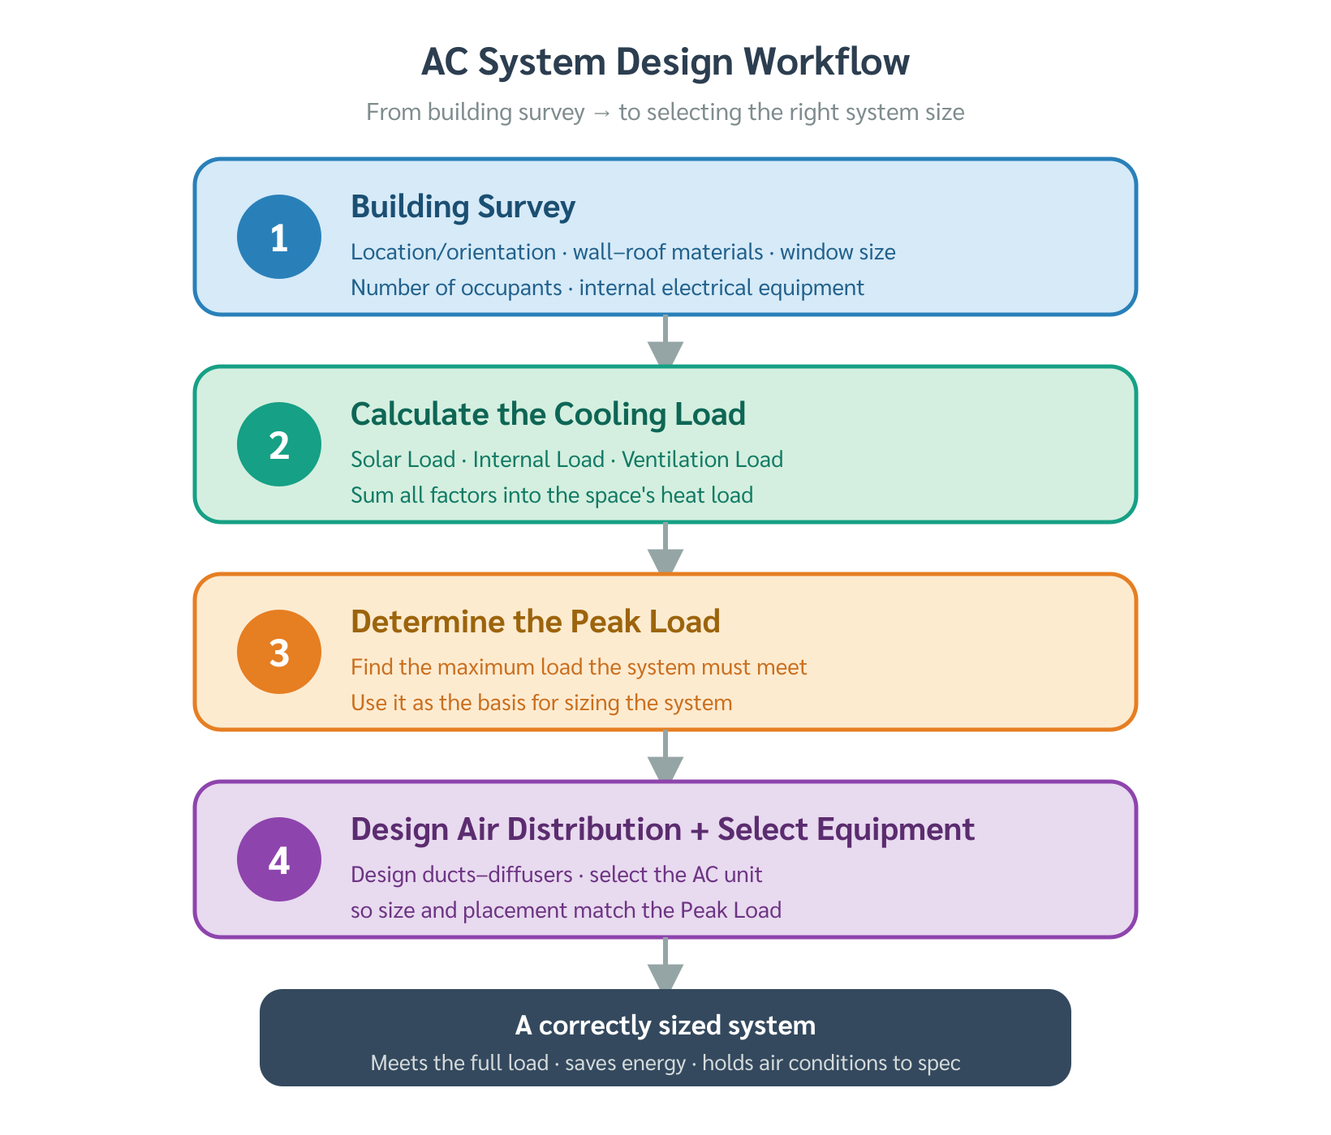
Design workflow from survey to equipment selection
Figure 1.4 — AC design workflow: from building survey through load calculation to equipment selection. (Source: Praphan, Ch. 1, p. 2)
A thorough building survey yields four direct benefits:
- Calculation accuracy — load estimates closely match actual operating conditions, reducing the risk of under- or over-sizing
- Appropriate equipment selection — system type and capacity match the building’s actual needs
- Energy efficiency — correctly sized equipment operates near its peak efficiency point rather than cycling on and off
- Long-term reliability — problems arising from poor design (insufficient dehumidification, noise, condensation) are eliminated before installation
Building survey procedures are covered in detail in Chapter 3. Load calculation methods follow in Chapters 4–7.

1.1.5 Scope of This Textbook
Although “air conditioning” encompasses both cooling and heating, as well as humidification and dehumidification, this textbook addresses only cooling-mode air conditioning.
Thailand’s tropical climate — characterized by high ambient temperatures and high humidity throughout the year — means that virtually all HVAC applications in this context involve removing heat and moisture from the conditioned space. Heating systems for cold climates are outside the scope of this course.
Source: Praphan, Ch. 1, p. 2

Summary — Topic 1.1
- Air conditioning = simultaneous control of Temperature + Humidity + Air Circulation + Air Cleanliness. It is not limited to cooling.
- Two purposes: Comfort AC (human thermal comfort) vs. Process AC (material/process requirements). Each has different design targets.
- Equipment must be sized for the peak cooling load, which occurs at different times depending on building type (offices: 3–4 PM; nightclubs: 9–10 PM).
- A building survey is the mandatory first step before any load calculation. Skipping it leads to systematic errors in sizing and design.
- This textbook covers cooling-mode AC only (Thailand context).

Reference: Praphan, Air Conditioning Engineering, Chapter 1 (Introduction), pp. 1–2 Status: draft — English version, written fresh from source — subject: aircon chapter: 1 topic: 1 title: “1.1 Examples — Air Conditioning Definition and Purpose” language: en status: draft tags: [aircon, chapter-01, fundamentals, examples, english] —

Examples — Topic 1.1: Air Conditioning Definition and Purpose

Example 1.1 — Identifying the Correct Purpose of Air Conditioning
Problem: A textile mill in Chiang Mai operates a weaving hall (500 m² floor area). The plant manager reports that threads break frequently during operation, especially during dry-season afternoons. A maintenance technician suggests installing a “larger air conditioner.” Evaluate this suggestion and identify the correct AC objective for this application.
Given: - Space: weaving hall, 500 m² (5,380 ft²) - Problem: frequent thread breakage, static electricity buildup - Ambient conditions in Chiang Mai dry season: ~95 °F (35 °C), 25–35 %RH
Analysis:
Thread breakage and static electricity in a textile mill are caused by low relative humidity, not by high temperature. The correct objective is Process AC — raising and maintaining RH in the weaving zone, not simply lowering temperature.
Installing a larger cooling-only unit would: - Lower temperature ✓ - Further reduce relative humidity ✗ (cold air holds less moisture → RH drops further) - Worsen thread breakage ✗
The correct solution is a system with humidification capability, sized to maintain RH ≥ 65–70 %RH in the weaving zone while also controlling temperature.
Conclusion: This is a Process AC application. The critical parameter is humidity, not temperature. A cooling-only unit with no humidifier would aggravate the problem.
Lesson: Always identify the AC purpose before specifying equipment.

Example 1.2 — Determining the Time of Peak Cooling Load
Problem: An engineer is designing the AC system for two buildings in Bangkok: - Building A: a 10-story corporate office tower - Building B: a nightclub/entertainment venue (3 floors, no windows)
For each building, identify the most likely time of peak cooling load and explain the dominant heat sources at that time.
Given: - Bangkok climate: hot-humid tropical, peak solar radiation typically 12:00–14:00 local time - Office: occupied 08:00–18:00, heavy glazing on east and west façades - Nightclub: opens 20:00, peak crowd 400 persons, high-density decorative lighting (50 W/m²)
Solution:
Building A — Office Tower:
Peak load time: 3:00–4:00 PM (15:00–16:00)
Heat sources at peak:
Source | Notes
Solar gain through glazing | West façade receives direct afternoon sun — maximum at ~15:00
Envelope thermal lag | Heat absorbed by concrete and glass since morning is re-radiated inward
Occupants | ~500 people × 250 Btu/h sensible each = 125,000 Btu/h (36.6 kW)
Lighting + equipment | Office lighting ~3 W/ft² + computers throughout floor
All four sources peak simultaneously at ~15:00–16:00 → this is the design hour.
Building B — Nightclub:
Peak load time: 9:00–10:00 PM (21:00–22:00)
Heat sources at peak:
Source | Notes
Solar gain | Zero — venue opens after sunset
Occupants | 400 persons × 450 Btu/h (high activity) = 180,000 Btu/h (52.7 kW)
Lighting | 50 W/m² × 600 m² = 30,000 W = 102,400 Btu/h (30 kW)
Latent heat dominant | Perspiration from dancing → latent gain >> sensible gain
By 21:00–22:00, the venue is at full capacity with all lighting on → peak load.
Answers: - Office tower: peak at 15:00–16:00 (solar + envelope storage + internal gains) - Nightclub: peak at 21:00–22:00 (occupant heat + lighting, latent-dominated)
Lesson: Peak load time is building-specific. Never assume noon is worst case.

Example 1.3 — Consequences of Skipping Building Survey
Problem: A contractor installs a 10-ton (35.2 kW) package unit in a 300 m² (3,230 ft²) server room based on a rule-of-thumb estimate of 400 Btu/h per m² of floor area without conducting a building survey. After installation, the room consistently runs 5–8 °F (3–5 °C) above setpoint. Identify what data the survey would have revealed and calculate the likely actual load.
Rule-of-thumb estimate used:
$$Q_{est}=400 \frac{\text{Btu/h}}{{\text{m}}^{2}}×300 {\text{m}}^{2}=120,000 \text{Btu/h}=10 \text{tons}$$
(SI: approximately 120 W/m² × 300 m² = 36 kW)
What a building survey would have found:
Heat Source | Actual Value | Btu/h | kW
IT equipment (servers) | 200 servers × 500 W each | 341,200 | 100.0
Lighting | 10 W/m² × 300 m² | 10,236 | 3.0
People (maintenance) | 2 persons × 250 Btu/h | 500 | 0.1
Envelope (roof + walls) | From survey data | 8,000 | 2.3
Total actual load |  | ~360,000 Btu/h | ~105 kW
Actual capacity required: ≈ 30 tons (105 kW) Installed capacity: 10 tons (35.2 kW) Shortfall: 20 tons (69.8 kW) — the system is 3× undersized
Conclusion: The standard 400 Btu/h·m² rule-of-thumb applies to typical office spaces. A server room has heat density 8–10× higher. A building survey identifying the actual IT equipment inventory would have revealed the true load immediately.
Lesson: Building survey data, not rules of thumb, must form the basis of load calculations.

Reference: Praphan, Ch. 1, pp. 1–2; ASHRAE Fundamentals Handbook Status: draft — English version — subject: aircon chapter: 1 topic: 1 title: “1.1 Exercises — Air Conditioning Definition and Purpose” language: en status: draft tags: [aircon, chapter-01, fundamentals, exercises, english] —

Exercises — Topic 1.1: Air Conditioning Definition and Purpose
Difficulty: ★ Easy · ★★ Moderate · ★★★ Challenging

Exercise 1 ★
A student claims: “Air conditioning means making a room cold.”
(a) State why this definition is incomplete. Use the four parameters of air conditioning in your answer.
(b) Give one example of an air conditioning application that does not involve cooling.
Answer
(a) The definition is incomplete because air conditioning simultaneously controls four parameters: temperature, humidity, air circulation, and air cleanliness. Cooling addresses temperature only. Humidity control, ventilation, and filtration are equally part of the system’s function. An air conditioning system that cools but fails to control humidity or provide adequate fresh air does not fulfill the engineering definition.
(b) Examples include: - A textile mill that humidifies the weaving zone to prevent thread breakage (humidity control, not cooling) - A warehouse in a cold climate that heats stored produce to prevent frost damage - A seed storage facility that dehumidifies at low temperature to preserve germination viability

Exercise 2 ★
Match each facility with the most critical air conditioning parameter and state the reason.
Facility | Most Critical Parameter | Reason
Hospital operating room | ? | ?
Cotton weaving mill | ? | ?
Computer server room | ? | ?
Art museum storage vault | ? | ?
Answer
Facility | Most Critical Parameter | Reason
Hospital operating room | Air cleanliness (filtration + positive pressure) | Prevent airborne infection of open surgical sites
Cotton weaving mill | Humidity (high RH, 65–75 %RH) | Maintain fiber flexibility, prevent static electricity and thread breakage
Computer server room | Temperature (precise cooling) | Servers generate very high heat density; overtemperature causes hardware failure
Art museum storage vault | Temperature + Humidity (tight simultaneous control) | Dimensional changes from temperature swings and moisture damage pigments, canvas, and paper

Exercise 3 ★
An office building in Chiang Mai is described as follows: - 5-story building, east–west long axis - 200 occupants, 08:00–17:00 Monday–Friday - Heavy glazing on the south façade
State the most likely time of peak cooling load and list the three dominant heat sources at that moment. Briefly justify each.
Answer
Most likely peak time: 14:00–15:00 (2:00–3:00 PM)
For a south-facing façade in the Northern Hemisphere (Chiang Mai, 18°N), direct solar radiation on the south wall peaks around solar noon but continues to drive heat gain through the glazing and envelope thermal mass into mid-afternoon.
Three dominant heat sources at 14:00–15:00:
- Solar gain through south-facing glazing — direct sun angle still favorable for south façade; glass transmits shortwave radiation directly into the space
- Envelope thermal lag — heat absorbed by concrete walls and roof since morning conducts inward with a 2–4 hour delay, adding to the afternoon peak
- Occupant sensible + latent heat — 200 occupants at sedentary office work each contribute ~250 Btu/h (73 W) sensible + ~200 Btu/h (59 W) latent = 90,000 Btu/h (26.4 kW) total from people alone
(Lighting and equipment are also significant but are approximately constant throughout the working day.)

Exercise 4 ★★
A contractor proposes to use a rule-of-thumb of 600 Btu/h per m² (190 W/m²) to size the AC system for a 200 m² (2,150 ft²) commercial kitchen in a hotel.
(a) Calculate the estimated cooling capacity in tons and kW.
(b) Identify four specific heat sources in a commercial kitchen that a building survey would need to quantify, and explain why the rule-of-thumb may be inappropriate for this application.
Answer
(a)
$$Q_{est}=600 \frac{\text{Btu/h}}{{\text{m}}^{2}}×200 {\text{m}}^{2}=120,000 \text{Btu/h}=10 \text{tons}$$
$$\text{SI: }190 {\text{W/m}}^{2}×200 {\text{m}}^{2}=38,000 \text{W}=38 \text{kW}$$
(b) Four heat sources a survey must quantify:
- Cooking equipment (ovens, ranges, fryers, steamers) — heat output varies enormously by equipment type and operating schedule; a single commercial fryer may emit 40,000–60,000 Btu/h (12–18 kW)
- Exhaust hood capture efficiency — not all heat from cooking equipment is captured by the exhaust hood; the uncaptured fraction enters the conditioned space
- Occupants (kitchen staff) — kitchen workers perform heavy physical activity; latent heat output can reach 950 Btu/h (280 W) per person, roughly 4× a sedentary office worker
- Steam and moisture from cooking — extremely high latent loads from boiling, steaming, and dishwashing that drive dehumidification requirements far beyond what a standard 600 Btu/h·m² rule assumes
A commercial kitchen can have actual heat densities of 1,500–3,000 Btu/h·m² (470–950 W/m²) — 3–5× the assumed rule-of-thumb — making a survey mandatory.

Exercise 5 ★★
Explain the logical basis for the statement: “If the AC system is sized to handle the peak cooling load, it will also handle all other operating conditions.”
Under what circumstance might this logic fail in practice, and what design provision addresses that failure?
Answer
Logical basis: The peak cooling load represents the maximum rate of heat gain the space will ever experience under design conditions. If the system can remove heat at least as fast as it enters at peak, then at any other time — when heat gains are lower — the system has surplus capacity and will easily maintain setpoint. The argument is monotone: peak capacity ≥ all other loads by definition.
When the logic can fail: The argument assumes the peak load calculation is correct. It fails if: - The building is later renovated (more equipment, more occupants, more glazing) beyond original assumptions - Climate change shifts outdoor design temperatures above the historical values used in the original calculation - A process change introduces a new internal heat source not present at the time of design (e.g., adding a server room inside an office that was originally designed as open-plan)
Design provision: Engineers typically apply a safety factor (SF) of 5–15% to the calculated peak load before specifying equipment:
$$Q_{design}=Q_{peak,calc}×(1+SF)$$
This margin accommodates calculation uncertainty, future load growth, and degradation of equipment performance over time.

Exercise 6 ★★★
A building survey for a 1,500 m² (16,150 ft²) department store reveals the following data. Calculate the total estimated cooling load and the required system capacity in tons and kW.
Heat Source | Quantity / Rate | Unit Heat Gain
Occupants (sensible) | 300 persons | 250 Btu/h per person
Occupants (latent) | 300 persons | 200 Btu/h per person
Lighting | 1,500 m² | 15 W/m²
Display equipment | 1,500 m² | 8 W/m²
Solar gain (glazing) | 200 m² south glass | 150 W/m²
Roof conduction | 1,500 m² | 12 W/m²
Ventilation (sensible) | 3,000 L/s outdoor air | ΔT = 10 °C
Ventilation (latent) | 3,000 L/s outdoor air | Δω = 8 g/kg
Hint: Use Q = 1.23 × L/s × ΔT (W, SI) for sensible ventilation; Q = 3,000 × L/s × Δω (W, SI) for latent ventilation.
Apply a 10% safety factor to the total load.
Answer
Step 1 — Calculate each component (SI):
Source | Calculation | Load (W)
Occupants sensible | 300 × 250 Btu/h × 0.293 | 21,975
Occupants latent | 300 × 200 Btu/h × 0.293 | 17,580
Lighting | 15 W/m² × 1,500 m² | 22,500
Display equipment | 8 W/m² × 1,500 m² | 12,000
Solar gain | 150 W/m² × 200 m² | 30,000
Roof conduction | 12 W/m² × 1,500 m² | 18,000
Ventilation sensible | 1.23 × 3,000 × 10 | 36,900
Ventilation latent | 3,000 × 3,000 × 0.008 | 72,000
Subtotal |  | 231,0
(Note: Ventilation latent: Q = 3,000 L/s × Δω [g/kg] × 3,000 J/g ÷ 1,000 = approx. value; use psychrometric chart for precision in later chapters.)
Step 2 — Apply simplified totals:
Category | Load (kW)
Sensible subtotal | ~141 kW
Latent subtotal | ~90 kW
Total before SF | ~231 kW
Step 3 — Apply 10% safety factor:
$$Q_{design}=231×1.10=254 \text{kW}≈72 \text{tons}$$
Answer: Required system capacity ≈ 72 tons (254 kW)
(Precise calculation requires full psychrometric analysis and ASHRAE load calculation procedures covered in Chapter 4.)

Reference: Praphan, Ch. 1, pp. 1–2; ASHRAE Fundamentals Handbook, Chapter 18 Status: draft — English version

